1. Download the nsdl-ss-user-setup-2.0.0_new.exe (New Form Signer Utility ) from the corporate Website <https://www.npscra.nsdl.co.in/> .
2. Save the file on your Desktop.
3. Double click on the nsdl-ss-user-setup-2.0.0_new.exe to install the same.



1. The setup application will be installed in the desired location as shown in figure below, click on the option ‘**Next’**.

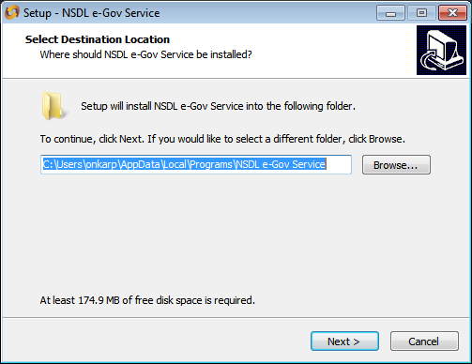

1. A page will be opened, click on the option ‘**Next’** as shown in **Figure** below**.**

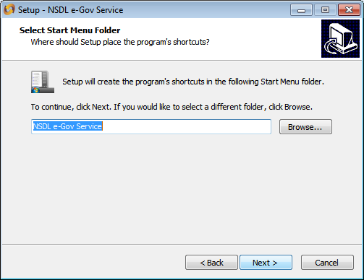

1. If user wants to create a desktop shortcut, tick the option of ‘**Create a desktop shortcut’** under head ‘**Additional shortcuts’** and click on ‘**Next’** button as shown in Figure below.

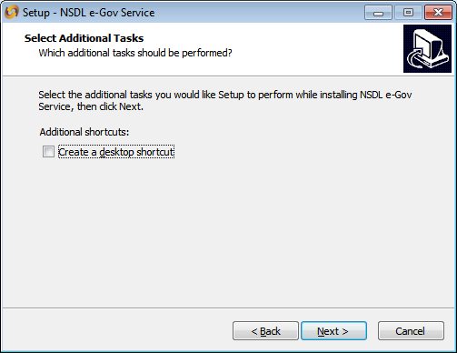

1. A page will be opened ‘**Ready to Install’** wherein the user should click on option ‘**Install’** as shown in Figurebelow.

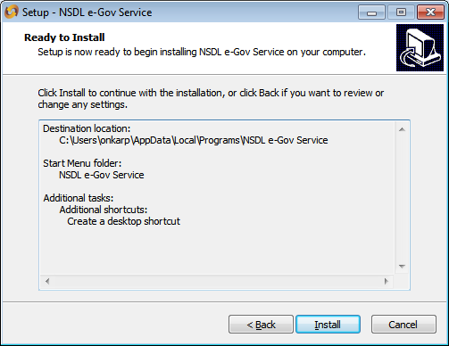

1. If below message is shown user should click on Ignore.

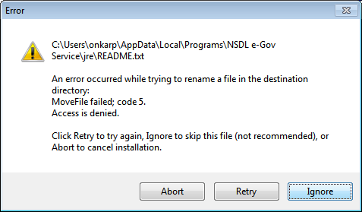

1. Program will be installed.

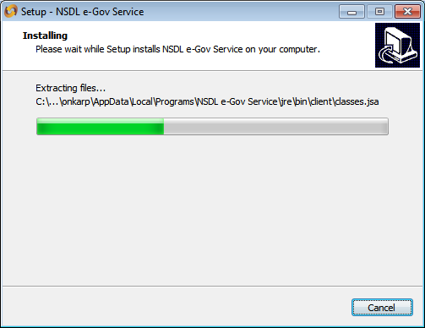

1. After successful installation of setup , window will be opened as shown in below

and then click on option ‘**Finish’.**

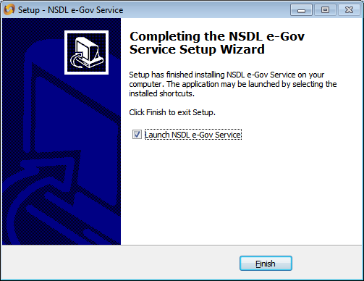

1. After successful installationa pop up message will be displayed as ‘**NSDL e-Gov Service started’** as shown in Figure below which means SAMOnline/CRA application is ready for use.

